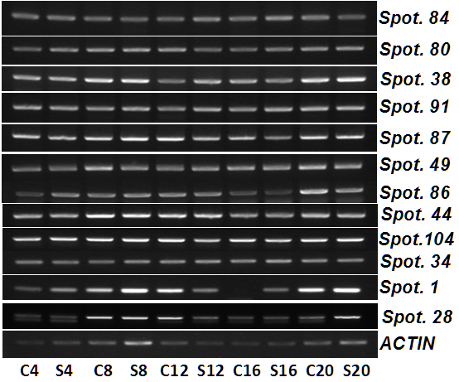

Fig. S1 Semi-quantitative PCR analysis of twelve genes and ACTIN of Amygdalus mira (Koehne) Yü et Lu leaves after drought treatment and re-watering, respectively. C4 and S4, day 4 under control and drought treatment, respectively; C8 and S8, day 8 under control and drought treatment, respectively; C12 and S12, day 12 under control and drought treatment, respectively; C16 and S16, day 16 under control and drought treatment, respectively; C20 and S20, day 4 under control and re-watering, respectively. Data of spots were listed in Supplemental Table S1 and Fig. 5.

